**Controversy over State and Local Deduction Repeal and Impact on California:**

* **Trump’s tax plan would cut the state and local (SALT) deduction to pay for tax cuts for the rich.**
* **State/local taxes** are important to our constituents because it **reduces the amount of Federal taxes owed.** 
  + The State and Local Deduction ensures the federal government can’t double dip by pretending working families still have the money they’ve already paid in state and local taxes – and then taxing it again.
* California has a comparatively high state income tax making the SALT deduction vital for many Californians.
  + According to the Tax Policy Center, about 44 million taxpayers claimed the deduction in 2014, including **6 million in California.**
  + The Republican tax plan would actually ***raise* taxes on 4,049,000 California households next year,** **or 22.8 percent of households in 2018.**
  + **Over 86 percent of taxpayers claiming the State and Local Deduction make under $200,000. And 56 percent of taxpayers claiming the deduction make under $100,000.**
  + The average tax increase on families nationwide earning up to $86,100 would be $794, a significant burden for middle-class families.
  + **See attached for the districts most impacted by elimination of the State and Local Tax Credit.**
* If eliminated, it would increase federal revenue by about **$1.3 trillion** over 10 years. SALT is a **large revenue raiser**—which is why it is so attractive to be eliminated.
* States with the highest state and local taxes are primarily Democratic states.
  + The top states for the deduction include: California, New York, New Jersey, Illinois and Texas.
  + **$96 billion in revenue would be lost in 2016 and $1.3 trillion would be lost over the 10-year window if SALT were eliminated.**
* The SALT deduction helps state and local governments fund public services that provide widely shared benefits.
  + That’s because, with this deduction, higher-income filers are more willing to support state and local taxes.
  + Repealing the deduction would almost certainly make it harder for states and localities — many of which already face serious budget strains — to raise sufficient revenues in the coming years to fund K-12 and higher education, health care, and other services.

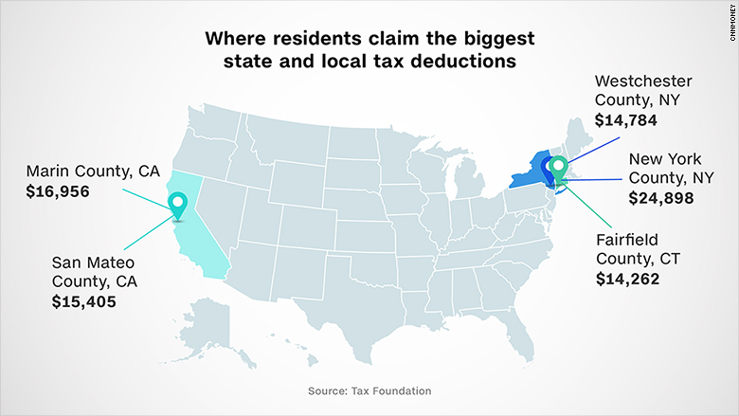

<https://www.irs.gov/statistics/soi-tax-stats-individual-statistical-tables-by-size-of-adjusted-gross-income>